### Commands

1. **FROM**:
   1. To specify the base image.
   2. Base Image may contain:
      1. Only OS Layer.
      2. And/or some Tools/Dependencies
      3. Installed Software such as Java, Node etc.
2. **WorkDIR**:
   1. By default, the working directory is root Dir of the container which can be referred with “/”.
   2. To change the default working dir, include the following instruction in Dockerfile.
      1. **WORKDIR /app**  
         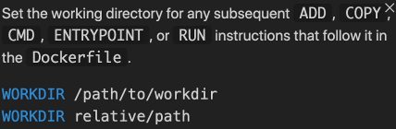
3. **COPY**
   1. 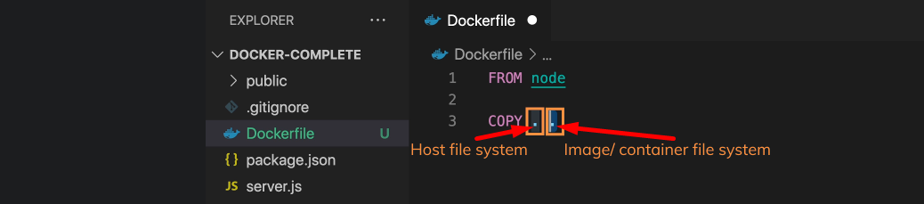
   2. Graphical user interface, text, application

      Description automatically generated